

**YEAR: 10**

**2017**

**SUBJECT: Science**

**NAME:**

**FORM:** **DATE:**

**TEST: Cosmetic Science**

**TIME: 45 minutes**

**QUESTIONS: 13 Short Answer (68 marks)**

**Answer all questions in the spaces provided.**

Total

**%**

**/68**

1. Explain what the term “ethics” means and give one example of an ethical dilemma related to the cosmetic science industry. (2 marks)

1. Label the three layers of hair in the diagram below: (3 marks)

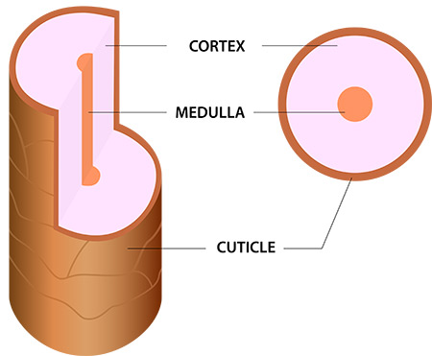

**A**

**B**

**C**

1. Match each layer of hair with its correct description by placing the corresponding letter in the table below: (3 marks)

|  |  |
| --- | --- |
| **DESCRIPTION** | **LETTER (A, B OR C)** |
| Contains melanin which gives hair its colour |  |
| Made up of scales which overlap to protect |  |
| May be absent, fragmented or segmented |  |

1. As your skin produces sebum to coat and protect each strand of hair, over time this can make your hair look greasy or dirty. **Describe** how shampoo works to clean your hair and why it is better than water alone. *You may like to use a diagram to help explain your answer.* (5 marks)

1. Why is it important to consider pH of shampoo and how does this affect the strength of the hair strand? (6 marks)

1. Label the five parts of the tooth in the diagram below: (5 marks)

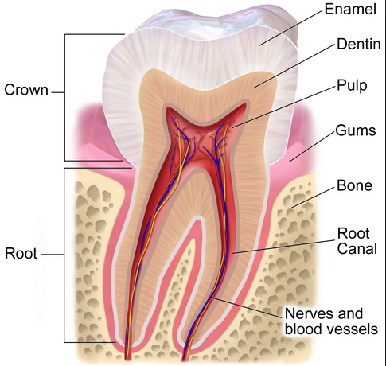

1. Fill in the missing information about the ingredients in toothpaste: (8 marks)

|  |  |
| --- | --- |
| **INGREDIENT** | **FUNCTION** |
| Abrasives |  |
|  | Smooth & creamy texture |
|  | Pleasant, refreshing taste |
| Thickeners & Binders |  |
|  | Makes foam |
| Sodium fluoride |  |
| Titanium oxide |  |
|  | Increases pH |

1. Explain the role of fluoride in maintaining healthy teeth. *You may like to use a diagram to help explain your answer.* (7 marks)

1. Label the anatomy of skin in the diagram below: (6 marks)

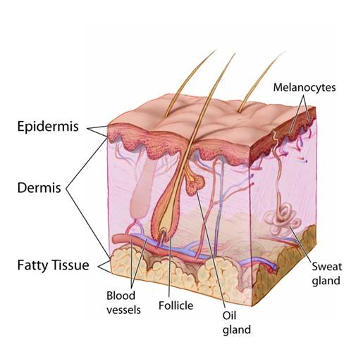

**vi**

**v**

**iv**

**iii**

**ii**

**i**

1. Match each label from the diagram of skin in question 9 to its function in the table below: (6 marks)

|  |  |
| --- | --- |
| **LABEL (i, ii, iii, iv, v or vi)** | **FUNCTION** |
|  | Location of hair growth for warmth and protection |
|  | Insulation |
|  | Provides protection |
|  | Carries oxygen and nutrition to tissues, removes waste products such as carbon dioxide |
|  | Secretes sweat to keep the body cool |
|  | Provides support and regulates temperature |

1. Describe the difference between UVA and UVB rays and state which ones SPF protects against. (5 marks)

1. Compare and contrast the two types of blockers in sunscreens and describe how each helps to protect the skin. (4 marks)

1. Match the name of the ingredient with its function in skin care product by drawing a neat and clear line between each: (8 marks)

|  |  |
| --- | --- |
| sodium laureth sulfate | thickening agent |
| glycerine | adjusts pH levels |
| allantoin | foaming agent |
| stearic acid | helps remove dead skin cells |
| salicylic acid | acts as a lubricant and hydrates skin |
| sodium hydroxide | dries up blackheads/whiteheads |
| glycolic acid | conditioner and skin protectant |
| myristic acid | forms bubbles for faster foaming |